**Personality Prediction Using Decision Tree**

* **Overview:** This application will predict the personality of an individual by asking the appropriate questions to the user. Personality is a complex and multifaceted construct, and accurately predicting it has a variety of practical applications, such as hiring and recruitment, marketing, and mental health diagnosis and treatment. Decision trees are a popular machine learning technique for classification problems, providing a transparent and interpretable model that can aid in determining which features are most important in predicting personality.
* **Why we need to predict personality?**
* psychological research
* clinical psychology
* counseling
* human resource management
* marketing
* **Methodology:** The dataset used in the analysis will be described in the report, which may include personality assessment measures, demographic information, and other relevant variables. The decision tree algorithm used, as well as any pre-processing or feature engineering steps taken to prepare the data, will be described.
* **Data Set:**

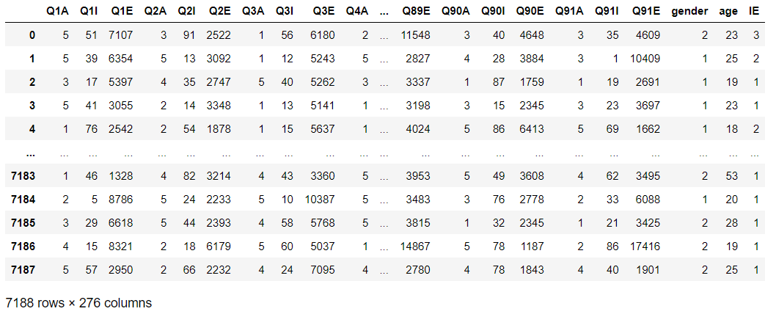

* **Data Set Description:**

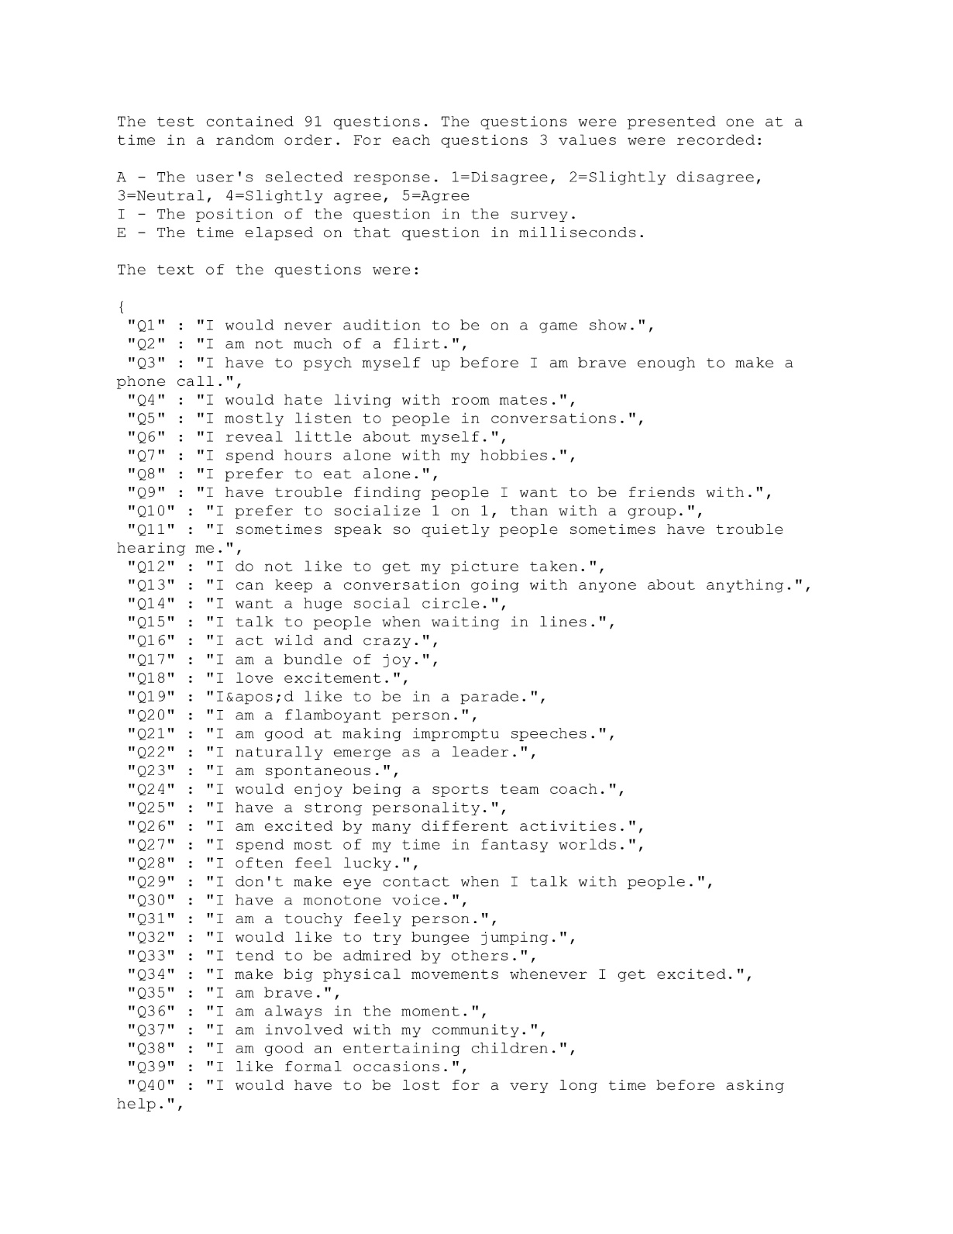

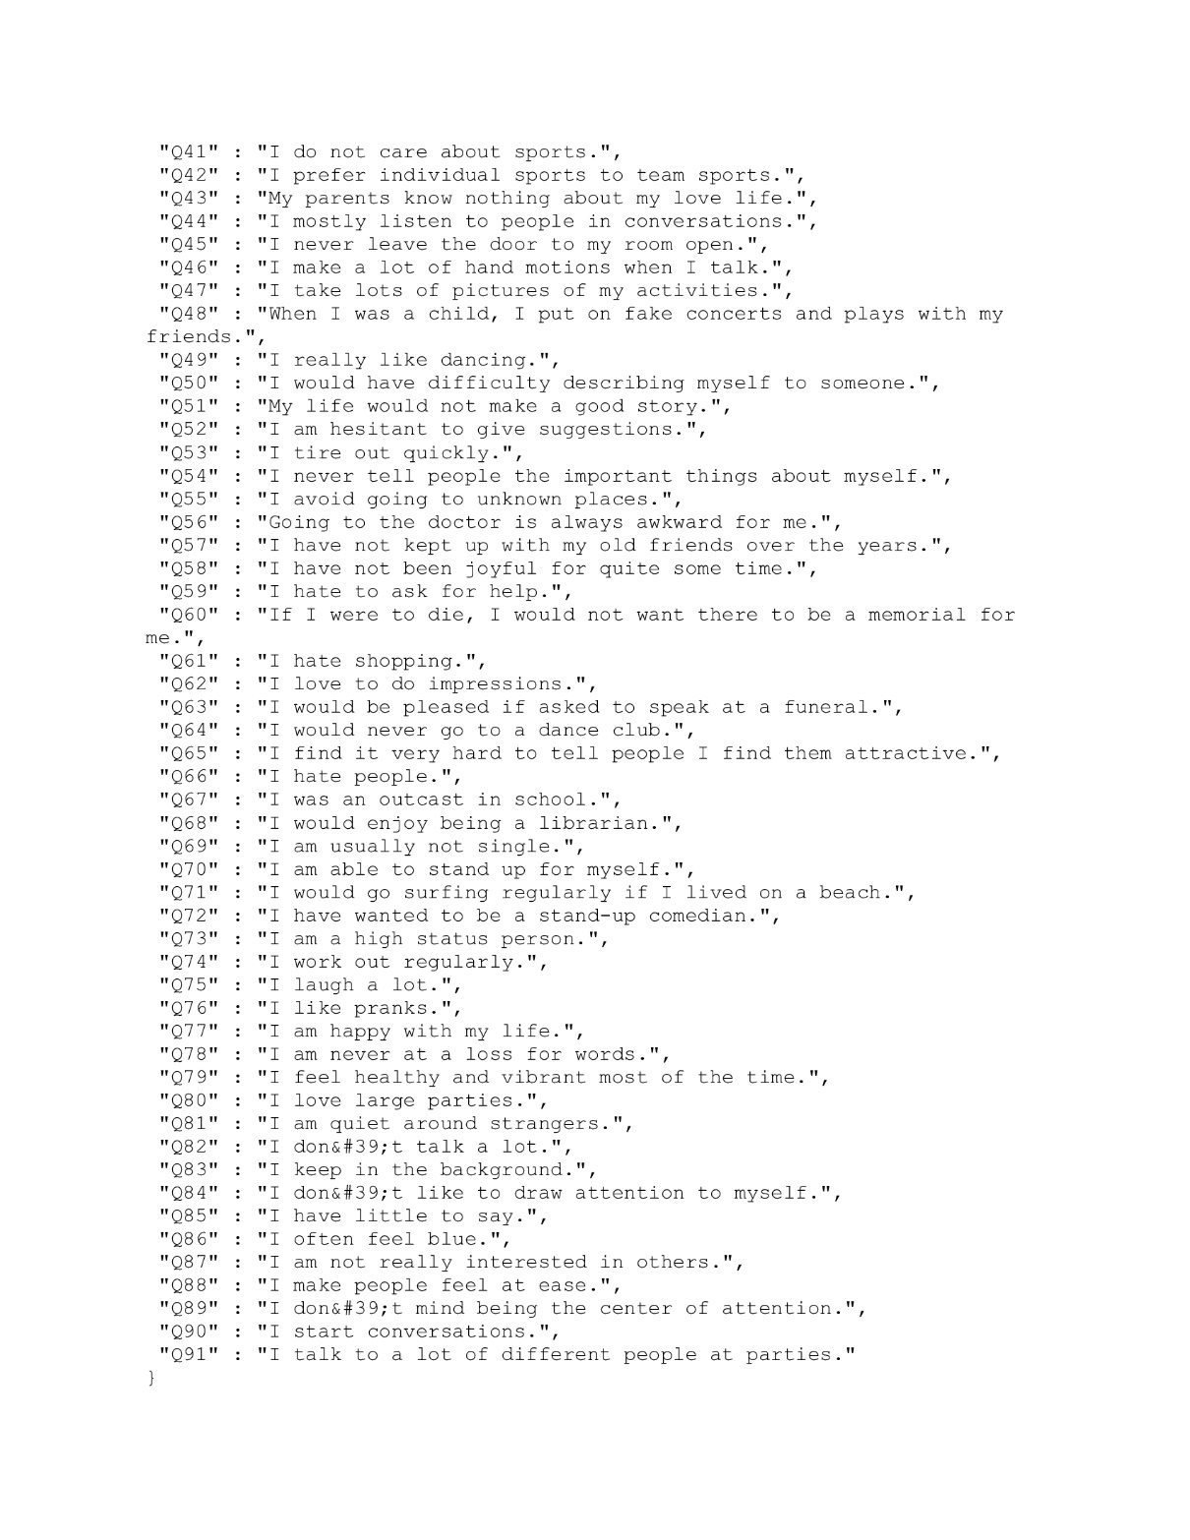

* **What is decision tree?**
* non-parametric supervised learning algorithm,
* hierarchical and tree structure
* it consists of a root node, branches, internal nodes, and leaf nodes.
* **Why is decision tree used here?**
* useful in situations where the data is complex and difficult to analyze using traditional statistical methods.
* model is easy to understand and can be visualized as a tree.
  + easy to implement and can handle both categorical and continuous data.
* **How is decision tree applied?**
  + **Input Used:**
    - Numerical Value: For scaling level of answer for each prompt 91 questions
    - 91 questions: Are features to decide personality type.
  + **Output Obtained:** 
    - Personality type is displayed stating introvert, extrovert, or ambivert.
  + **Logic Used:**
* **Gini index value:** Used for each feature question to determine whether user is of a particular personality type.
* **Application**
  + Can be used in schools/universities while selecting subjects.
  + Can be used by recruiting firms for taking personality tests.
  + **Different parts of Future application:**
* **Data Source:** MongoDB (No SQL Database) Predefined values for feature questions for decision tree.
* **Python Django:** Framework to connect knowledgebase with user interface.
* **User Interface:** Web page which asks user the feature questions (page is designed in HTML and CSS)
* **Application Cycle:**
  + Gather past user data.
  + Check /predict more accurate current results based on the past values for the outcome, application maintains a centralized accuracy value for the result variable (for future usage)
  + Ask user again if the suggested new value is correct or not (based on past result values)
* **Output:**

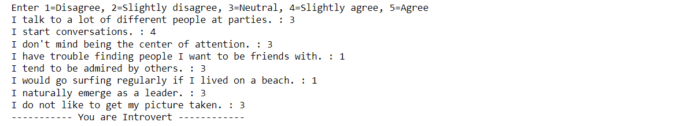

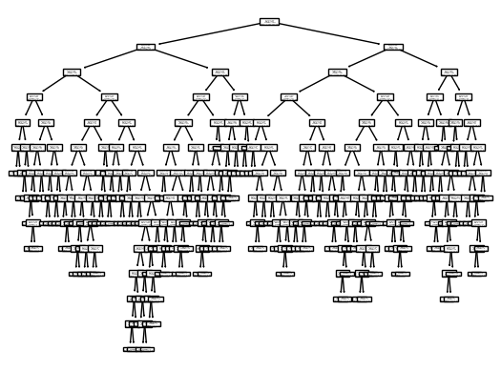

* **Results:** The findings of the analysis will be presented in the results section, including the decision tree model's accuracy in predicting personality traits as well as any insights gained from the feature importance rankings. To aid in the interpretation of the results.
* **Discussion:** The discussion section will place the findings in the context of the larger literature on personality prediction and decision tree modelling. The study's limitations will be discussed, as will potential future research directions. The findings' practical implications, particularly their relevance to real-world applications such as hiring and mental health treatment, will also be discussed.
* **Conclusion:** The report's conclusion will include a summary of the key findings and their implications, as well as any recommendations for future research or practical applications. Overall, the report seeks to provide a comprehensive overview of the use of decision trees in personality prediction, as well as its potential to contribute to our understanding of this complex and important construct.